Reliable Data Distribution Services in Cloud Computing
ABSTRACT
The cloud computing technologies have been rapidly risking in recent years due to its ready expansion, high reliability, low cost and other advantages. Therefore, in combination with the advantages of cloud computing in terms of technology and cost, the research on cloud-computing-assisted reliable data distribution technologies is a practical and challengeable topic. We will present a scenario for increasing the availability of services in cloud. We will mainly focus on classification of data with ensured security and making them available to the nearest data centers. This study aims on increasing the availability of services in cloud according to the classification and replication strategies that have been defined. the in-depth analysis on the characteristics of reliable data distribution and cloud computing and their relations, the innovative proposing of a model of forwarding structure of cloud-computing-assisted reliable data distribution, the research on the cloud-computing assisted data recovery and error control theory on the basis of aforementioned model together led to the introduction of a set of readily deployable, cloud-computer assisted, and reliable data distribution service system.
Existing System
Cloud computing provides the thousands of server as a rent and executes the application on most powerful system available anywhere and anytime. It deals with data storage application, infrastructure using service oriented technology. While the threat concept arises from the intruders and hackers, makes the information very much vulnerable to unauthenticated access and alterations. So they are focusing their attacks directly or indirectly through e- Government. Indirect Tampering of information such as finding loopholes in the TCP / IP model caused by the negative attacks
Disadvantages
- Less maintenance
- Indirect Tampering of information
Proposed System
This paper designs and implements a A Reliable Data Distribution Solution Assisted by Cloud Computing, called RDDSACC. While designing RDDSACC, we consider an multicast infrastructure in combination with the advantages of cloud computing in terms of technology and cost for solve the problem. Theoretically, the main contributions of this paper are as follows: a) a new data forwarding model which is assisted by the cloud virtual machine and is open to the reliable data distribution is proposed. Methods for constructing the relevant structures are offered so as to overcome the structural obstacles in the forwarding of data and to provide the reliable data distribution with new room for performance improvement and abilities to solve relevant problems. According to our investigation, no researches and results based on the above ideas could be retrieved from the database. b) In lights of the possible data error or loss on the process of reliable data distribution, a technology for data recovery and error control based on the cloud-computing assistance is proposed. In combination with low costs for cloud computing and adjustment of resources on demand, this technology is capable of significantly improving the reliability of data distribution. Our research results show that the organic combination of cloud computing and reliable data distribution has the apparent innovative nature. c) In combination with the current practical status of cloud computing, a readily-deployable, could computing- assisted and reliable data distribution service system is innovatively proposed
Advantages
- Performance improvement and abilities to solve relevant problems.
- Protected data to quickly and securely share real-time decision support and data real-time.
System Architecture
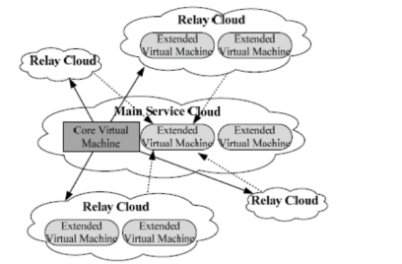
Fig. The system architecture of RDDSACC

Hardware Requirements:

Processor - Pentium –IV
- Speed - 1.1 GHz
- Ram - 256 MB
- Hard Disk - 20 GB
- Key Board - Standard Windows Keyboard
- Mouse - Two or Three Button Mouse
- Monitor - SVGA
Software Requirements:
- Operating System - Windows XP
- Coding Language - java

